 | Year 1 | Year 2  EYFS - Expressive Arts and Design (early years goal): Explore, use and refine a variety of artistic effects to express their ideas and feelings. Use and explore a variety of materials, tools and techniques, experimenting with colour, design, texture, form and fuction. Share their creations and create collaboratively, explaining the processes they have used. | Year 3 | Year 4 | Year 5 | Year 6
 | School Days | Towers, Tunnels, Turrets | Scrumdiddlyumptious | Potions | Greece - Gods and Mortals | Darwin’s Delight
Autumn 1 | Skill/keywords: line, pattern, texture, shape  Materials: Pencil, crayon, clay  Progression of skills:  1) Take rubbings of different textures and patterns which can be found around our school.  2) Exploring the shape of different features of the school buildings through sketching – think about the quality of lines and shapes.  3) Mark making with pencil or pencil crayon – shading, hatching and cross hatching.  3) Outside art: sketch the school. | Skill/keywords: Shape, line, pattern, printing, texture,  Materials: Pencil, crayons, paint  Progression of skills:  1) Take rubbings of different surfaces and textures around school – brick, wood, tarmac. Label with keywords – rough, bumpy, smooth, lines…  2) Use different materials to experiment with printing – pasta, cotton wool, cardboard, polystyrene  3) Use sponge printing to create a stone wall pattern – experiment with size of bricks and different colours.  4) Design and print a castle. | Skill/keywords: Observational drawing, shape, pattern, and texture, form.  Materials: Pencil, chalk  Artist suggestion: Giuseppe Arcimboldo  Progression of skills:  1) Look at the work of the artist. Fruit and veg portraits or nature portraits – creating a portrait using food items – think about shape, form and composition.  2) Texture of different types of fruit and veg. What mark making techniques could you use e.g., shading, dots, cross hatching, blending. Add keywords – circles, lines, bumps, holes, smooth, shiny  3) Shading circles using different techniques – light and dark areas to look 3D.  4) Observational drawing of a piece of fruit or veg in pencil.  5) Colour wheel using chalk – blending primary and secondary colours.  6) Observational drawing, adding colour. | Skill/keywords: Observational drawing, tone, line, shape, photography  Materials: Pencil, charcoal  Progression of skills:  1) Identify what makes a drawing look 3D – tone, light and dark areas.  2) Use a pencil and rubber to replicate light and dark areas – hatching, stippling, blending, smudging, rubbing, shading.  3) Photography of potion bottles – editing and manipulating images for effect. light/dark/colour/ contrast.  4) Austin’s Butterfly - Observational drawing of a bottle in pencil.  5) Charcoal/chalk drawing – reverse – white onto dark. | Skill: Observational drawing, sculpture, shape, form, pattern, moulding  Materials: Pencil, clay  Progression of skills:  1) Mark making with pencil. Creating light and dark with different techniques. Annotating with personal comments.  2) Researching Greek patterns often used on pots and recreating in sketch book.  3) Austin’s Butterfly - Half/half pencil sketch of pots focussing on symmetry and shape and continuing pattern.  4) Using research to design own clay pot – think about shape, size and patterns inspired by ancient Greece.  5) Make a clay coil pot. | Skill: Observational drawing, texture, shape, size, tone  Materials: Pencil, crayon, pencil  Artist suggestion: Lucy Arnold  Progression of skills:  1) How to use a pencil to create the texture of different animals. Pencil techniques – hatching, cross hatching, stippling, shading, rubbing – e.g., dolphin – smooth and shiny so use finger blending and rubbing, wolf – hair so use hatching, snake – scales so use circling...  2) Step by step drawing of an animal – identifying light and dark areas and adding shadow – tone practice using pencil and pencil crayon.  3) Look at the fine artwork of Lucy Arnold. Experiment with shading a layering different colours of pencil crayon to recreate the colours and effects.  4) Final piece – butterfly – watch the Austin’s Butterfly video and discuss the importance of editing. Evaluate with personal comments.
 | Splendid Skies | Beat Band Boogie | Tribal Tales | Playlist | Stargazers | A Child’s War
Autumn 2 | Skills: Colour mixing, blending  Materials: paint, collage mixed materials, wax crayon and watercolour  Artist suggestion: Vincent Van Gogh  Progression of skills:  1) Experiment with paint – use paint to create patterns and textures using different colours, talk about the colours which you could use to represent day and night.  2) Colour mixing – primary and secondary colours.  3) Look at the patterns in Van Gogh’s night sky – create using light coloured wax crayons. Use dark blue watercolour wash over the top.  4) Van Gogh style sky using paints. Use different colour paper to cut out the shape of houses and collage onto background. Use a contrasting colour for the windows. | Skills: colour mixing, mixed media, shape, line  Materials: paint, collage/mixed media  Artist suggestion: Jackson Pollock  Progression of skills:  1) Look at some examples of work by Jackson Pollock – think about how what thoughts he might have had whilst creating these pieces. Different types of mark making, line, colour and feelings.  2) Colour wheel mixing – watercolour paint  3) Loud and quiet colours – mark making to music/sound effects.  4) Large scale mixed media artwork – group work, mark making to music (paint, collage, felt tip). | Skills: mark making, shape, line, texture  Materials: charcoal, chalk, base materials  Progression of skills:  1) Study Neolithic patterns and symbols (see cornerstones)  Mark marking – Neolithic patterns using charcoal – experiment with line, blending and smudging.  2) Using different materials as a base – use chalk or paint on cardboard, sandpaper, tea stained paper, fabric scraps – what effects do you like and why?  3) Create cave art on sandpaper or brown paper – use chalk and create own Neolithic inspired patterns.  4) Collect materials to use for weaving – newspaper, string, wool, twine. Make a small woven square thinking about which materials work the best and why. | Skills: Mark making, shape, line, shape, digital art  Materials: digital, crayon, pencil, pen, chalk  Artist suggestion: Wassily Kandinsky  Progression of skills:  1) Investigate work by Wassily Kandinksy – what shapes/forms can be seen. How do we know it is abstract – feelings, keywords.  2) Mark making to different sounds – pen, pencil, crayon, chalk.  3) Create own soundscape inspired by music.  4) Use Paint on laptops to create a digital soundscape. Layers of different music – composition, shape, texture. | Skills: Colour mixing, shape, form, layering  Materials: pencil, chalk, paint  Artist suggestion: Peter Thorpe  Progression of skills:  1) Explore the colours of space, different planets/moon – collage of colours in sketchbooks  2) Colour mixing using chalk – primary, secondary, tertiary  3) Look at art work by Peter Thorpe. Think about the effects of the bright colours. Use chalk to recreate some of the effects.  4) Use chalk pastels to create a backdrop of deep space – blending and merging colours.  5) Use chalk to create a planet or rocket – blending brighter colours – complimentary colours – think about what will stand out against background. | Skills: Perspective, line, form, space  Materials: Ink and wash, chalk/ charcoal, photography  Artist suggestion: Henry Moore  Progression of skills:  1) What is perspective? Research scenes with perspective. Taking photographs (street scenes) using perspective.  2) Drawing to a point – shapes/lettering with perspective (one-point)  3) One-point perspective street scene sketch – inspired by research or imagination.  4) Adding ink and wash to street scene – darker and lighter areas.  5) Underground bomb shelter inspired perspective art inspired by Henry Moore – light chalk on dark background.
 | Bright Lights Big City | Land Ahoy - Explorers | Pharos | I am Warrior | Traiders and Raiders - Vikings | Frozen Kingdom
Spring 1 | Skills: shape, colour  Materials: Paint, collage/mixed media  Artist suggestion: Paul Klee  Progression of skills:  1) Explore what can be seen in paintings by Paul Klee.  2) Background – splattering on dark paper to create a starry sky.  3) Shapes of buildings – think about height and different colours. Bright squares for windows. | Skills: Shape, line, pattern  Materials: pencil, paint, collage materials, wax crayons  Progression of skills:  1) Use pencil sketching and lines to draw underwater patterns and creatures. E.g. waves, starfish, fish…  2) Sketch a pirate ship using different pencil skills – use long and short hatching, cross hatching, circling etc.  3) Experiment with watercolour wash – sea patterns and creatures.  4) Final piece – watercolour and wax resist ocean – collage boat | Skills: Collage, pattern, texture  Materials: Mixed media (collage), paint, pencil, printing blocks  Progression of Skills:  1) Use pencil to experiment with patterns – repeating patterns.  2) Printing with repeating patterns – use ideas from L1 to inspire their printing block.  3) Look at pictures of Egyptian collars and jewellery. Design own collar thinking about patterns and shapes.  4/5) Make Egyptian collars – large paper cut out. Layer with collage materials – tissue paper, cardboard, tinfoil, pasta… Paint appropriate colours. | Skills: Form, shape, sketching, repeated pattern, collage  Materials: Pencil, collage mixed media  Progression of skills:  1) Research and draw examples of patterns and shapes from mosaics from Roman era.  2) Create own mosaic pattern using inspiration from research and appropriate Roman colours.  3) Experiment with ripping, cutting and layering collage materials.  4) Use collage of different materials to create Roman mosaic.  5) Use Roman inspired patterns to carve a clay tile. | Skills: shape, pattern, collage  Materials: Pencil, Pen, string, card, foil, felt tip pen, printing block and paint  Progression of skills:  1) Investigate Viking jewellery and armour. Look for patterns and sketch these into sketch books.  2) Designing a Viking brooch based on pattern research.  3) Practise building up a 3D pattern by gluing string on cardboard or paper.  4) Create a Viking brooch – base shape, draw pattern in pencil, glue on the string in the pattern. Cover with foil and press into the gaps. Use felt tip to add colour. | Skills: pattern, experimentation, colour mixing  Materials: Chalk, paint  Progression of skills:  1) Colour mixing using paint – primary, secondary and tertiary colours.  2) Colour mixing using chalk pastels – compare to using paint – easier/harder? Why?  3) Tint, shade and tone.  Experimenting with adding white (tint), grey (tone) and black (shade).  4) Use chalk pastels on dark paper to create northern lights piece.
 | Paws, Claws and Whiskers | Street Detectives | Tremors | Blue Abyss | Alchemy Island | Tudors
Spring 2 | Skills: Pattern, texture, layers  Materials: Collage materials, paint  Artist suggestion: Henri Rousseau  Useful link: https://www.blowingrockmuseum.org/athome/draw-tiger-lesson-may  Progression of skills:  1) Look at some photos of different big cats. What colours do you see? Textures and patterns Recreate using paint or pastels around a photo in sketch books.  2) Look at work by Henri Rousseau.  Use tissue paper and other collage materials to create a jungle effect on the page. Tearing, cutting, scrunching and crinkling to give different effects.  3)Final piece: Tiger in the jungle collage inspired by Henri Rousseau. Focus is on the collage of the jungle so could provide them with a tiger outline. | Skills: Line  Materials: pencil, crayon, chalk, foil  Artist suggestion: L. S. Lowry  Progression of skills:  1) Look at a pieces of artwork by Lowry. What can you see in the image? Where might the people be going? How are they moving? How are they feeling? Why?  2) Experiment with drawing shapes of buildings inspired by Lowry. Use chalk or crayon to shade.  3) Use pencil and crayon to try drawing people inspired by Lowry. Think about their body language and the way they are walking.  4) Use clay/wire/ pipe cleaners and tinfoil to create Lowry style people. Create a class street scene. | Skills: Colour mixing, pattern, texture  Materials: Paint, straws  Artist suggestion: Andy Warhol  Progression of skills:  1) Look at Andy Warhol’s volcano painting. Think about why he has used red and yellow for the volcano itself – angry, stands out. What effect might he be trying to create in the background? Smoky sky etc.  2) Blow painting with straws - practice combining colours and patterns.  3) Explosion painting – use blow painting technique to create the illusion of an explosion. | Skills: Colour mixing, texture, pattern  Materials: Printing blocks, paint, oil pastel, wire  Progression of skills:  1) Look at pictures of sea creatures. Recreate the patterns, textures and colours using painting or pastels.  2) Look closely at a starfish. Observational drawing using pencil, ink and wash.  3) Printing practice – Use small blocks to practise patterns and printing into sketchbooks – using different colours.  4) Starfish printing final piece – different colours.  5) Wire starfish | Skills: Photography, line, texture, colour  Materials: Paint, pencil  Progression of skills:  1) Photography of grand doors in town – Ashbourne town hall.  2) Grid method sketch of door.  3) Imaginative art – linked to Narnia through the wardrobe. Watercolour sky and silhouette of lamppost/trees. | Skills: Observational drawing, line, pattern, shape, form, modelling  Materials: Clay, pencil, paint  Progression of skills:  1) Observational drawing of a rose – shape of petals – use different materials and create a mood board. Pencil, ink and wash, paint. Evaluate what they like and why.  2) Tudor rose sketch – use different materials to experiment with – ink and wash, chalk or oil pastel – evaluate the effects of each.  3) Clay Tudor rose and paint
 | Enchanted Woodland | Scented Garden | Mighty Metals | Traiders and Raiders | Scream Machine | Hola Mexico
Summer 1 | Skills: Colour mixing, line, pattern and texture  Materials: wool, string, paint  Artist suggestion: Georgia O’Keeffe  Progression of skills:  1) Nature printing – leaves, stones, twigs  2) Colours and shapes of trees – explore Georgia O’Keeffe’s choice of colours. What time of year could it be? Finger/paintbrush painting – link with times of the year and colours.  3) Create a landscape (trees and sky) inspired by Georgia O’Keeffe. Watercolour wash for blue sky. | Skills: Colour mixing, pattern and form  Materials: Paint  Artist suggestion: Claude Monet  Progression of skills:  1) Monet’s waterlilies – use finger painting to blend colours and recreate the colour theme. Mini fact file about the artist.  2) Photography of nature in school/local area.  3) Observational drawing using grid method.  4) Paint drawing. | Skills: Line, pattern, texture, form, shape  Materials: Cardboard, foil, felt tips/paint  Progression of skills:  1) Experiment with making patterns using string and glue.  2) Experiment with laying foil over string to give an embossed look.  3) Textured string and foil art – design  4) Textured string and foil art – make – add colour using paint or felt tip.  5) Foil sculptures | Skills: Pattern, texture, line, shape, form  Materials: Clay, pencil, paint  Progression of skills:  1) Dragon eye close up – colours and textures of scales. Experimentation in sketch book.  2) Observational drawing – shape, pattern – grid method.  3) Design own dragon eye – think about carving and also building up to create texture.  4) Make from clay  5) Paint | Skills: Colour mixing, line, pattern and texture  Materials: string, PVA, paint, pencil  Progression of skills:  1) Experiment with close up patterns and lines from mechanisms and fair ground rides. – Use a mixture of pen, pencil and fine liner.  2) Explore the colours of a fair. Dark sky with bright, loud colours. Create a mood board page in sketch books.  3) Abstract art – soak pieces of dark string in PVA glue, pull them out and drop onto sketchbook or card. Let them fall randomly creating the effect of chaos and roller coasters.  4) Used mixed media – pens, oil pastels and paint to fill in the gaps between the string. | Skills: pattern, colour, shape, form  Materials: Newspaper, glue, paint, felt tip, crayon  Progression of skills:  1) Explore patterns/ colours on Day of the Dead masks.  2) Design own mask using traditional colours and patterns – think about contrasting colours.  3) Papier mache half balloon.  4) Paint white as a base.  5) Design – add more paint / felt tip for colour. Use a dark pen for design details.
 | Moon Zoom | Beach Combers | Urban Pioneers | Burps, Bottoms and Bile | Beast Creator/ Allotment | Blood Heart
Summer 2 | Skills: Colour mixing, texture  Materials: Clingfilm, paper plates  Progression of skills:  1) Experiment with creating textures and patterns with paint – finger painting, brushes, sponging, paint blowing, splattering.  2) Paper plate planet. Mix 2-3 colours on a paper plate – use a layer of cling film to move the paint around and leave to dry with cling film on. Peel off when dry.  3) Add planet to dark background and add rings or stars in background using light chalk. | Skills: texture, colour  Materials: Sand, salt, paint, netting, collage  Progression of skills:  1) Seaside colours experiment. Mixing sand and salt in paint for textures.  2) Patterns of things that we find at the beach – nets, shells, sand, pebbles.  3) Shell line drawing  4) Transfer simple line drawing to a printing block – line and stippling to create texture. | Skills: shape  Materials: Spray paint, cardboard  Artist suggestion: Banksy  Progression of skills:  1) Opinions and class debate about Banksy’s artwork.  Who is Banksy?  Is it art?  What do some of his pieces mean?  2) Stencil art: Create simple stencil shapes with masking tape. Use chalk over the top then peel away.  3) Create own stencil out of cereal box. Must be a simple shape/design.  4) Use stencil and spray paint. | Skills: Shape, line, form, space  Materials: Pen, pencil, felt tip  Artist suggestion: Julian Opie; Henry Moore  Progression of skills:  1) Exploring abstract sculptures (Henry Moore) and body language.  2) Drawing outlines in pencil. Using wooden models to sketch body shapes.  3) Photography and sketching different body shapes and poses. | Skills: Pattern, line, shape  Materials: Pencil, fine liner  Artist suggestion: Rosalind Monks  Progression of skills:  1) Look at artwork by Rosalind Monks - experiment with using intricate patterns used by the artists in sketchbooks.  2)Look at the similarity and differences of Darwin’s insect drawings (see Curriculum Maestro) and Rosalind Monks’s drawings. Annotate in sketch books.  3) Patterns – Twinkl (Drawing skills teaching pack – drawing texture)  4) Insect outlines – experiment with shapes and outlines of different insects.  5) Final piece – chosen insect shape filled with patterns. | Skills: Line, shape, space  Materials: pencil, pen  Artist suggestions: Pablo Picasso; Arturo Espinosa  Progression of skills:  1) Drawing what you feel and see – pinecones. Continuous line, not allowed to remove pencil from the page.  2) Explore the work of different continuous line artists – Picasso and Espinosa – annotate with thoughts and opinions, thinking about what they like/dislike; level of detail; realistic or not?  3) Continuous line features – facial features in pencil. Can do this from a photograph. Eyes, ears, lips. Think about the style of Picasso and Espinosa.  3) Wire sculpting inspired by Picasso.

Appendix A: Suggested artists’ work:
Year 1 – Autumn 2 – Van Gogh  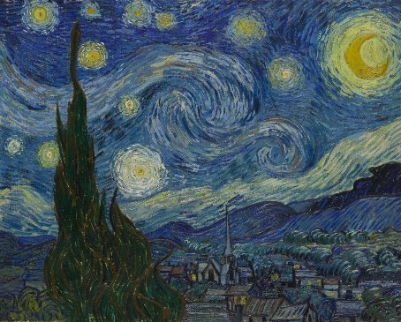 | Year 1 – Spring 1 – Paul Klee  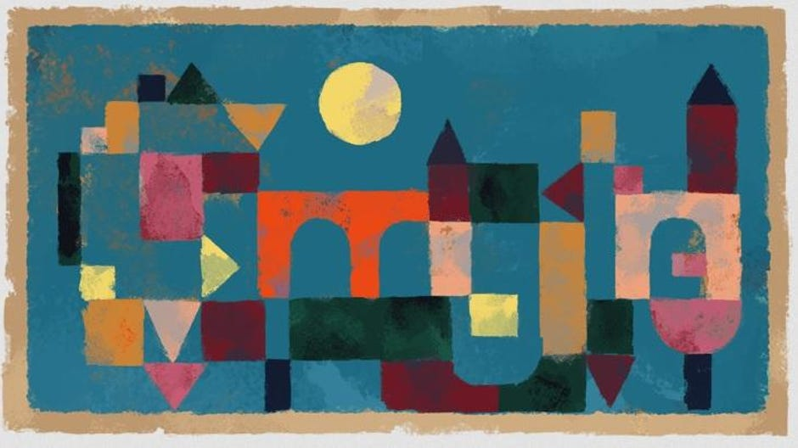 | Year 1 – Spring 2 – Henri Rousseau  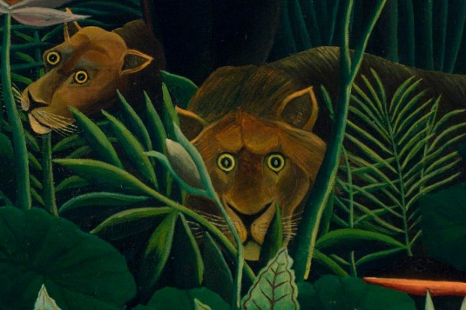
Year 1 – Summer 1 – Georgia O’Keefe  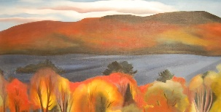 | Year 2 – Autumn 2 – Jackson Pollock  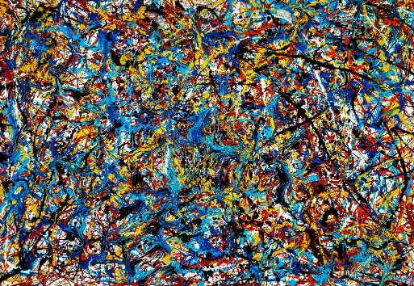 | Year 2 – Spring 2 – Lowry  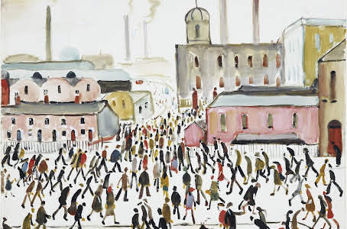
Year 2 – Summer 1 – Monet  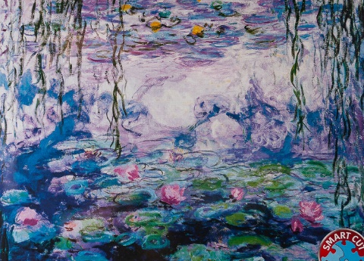 | Year 3 – Autumn 1 - Giuseppe Arcimboldo  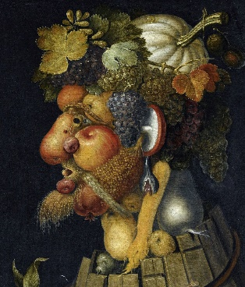 | Year 3 – Spring 2 – Andy Warhol  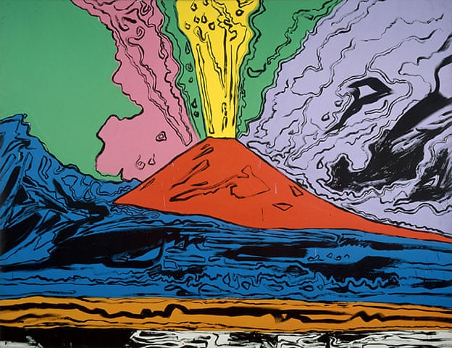

Year 3 – Summer 2 – Banksy  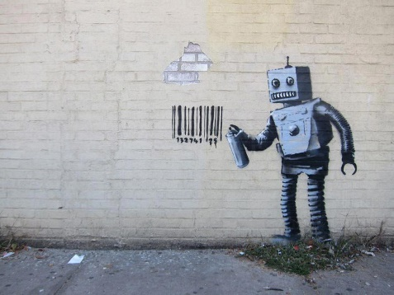 | Year 4 – Autumn 2 – Wassily Kandinsky  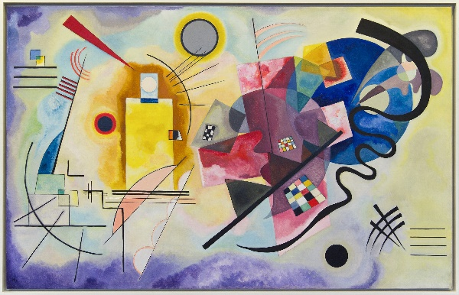 | Year 4 – Summer 2 - Julian Opie / Henry Moore  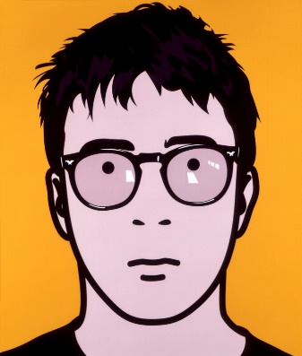  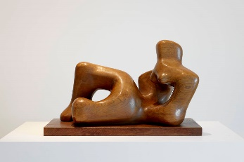
Year 5 – Autumn 2 – Peter Thorpe  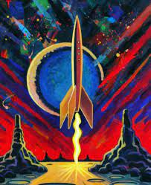 | Year 5 – Summer 2 – Rosalind Monks  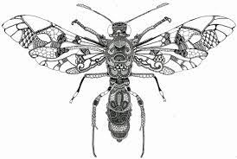 | Year 6 – Autumn 1 – Lucy Arnold  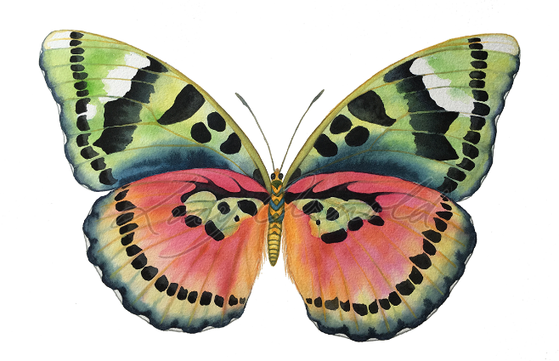
Year 6 – Autumn 2 – Henry Moore  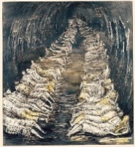 | Year 6 – Summer 2 – Picasso / Arturo Espinosa  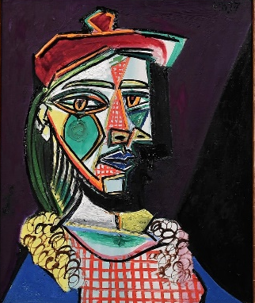  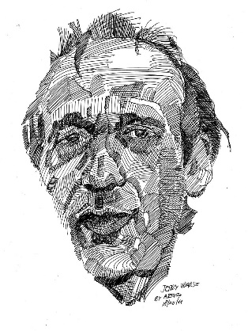

Appendix B: Colour skills
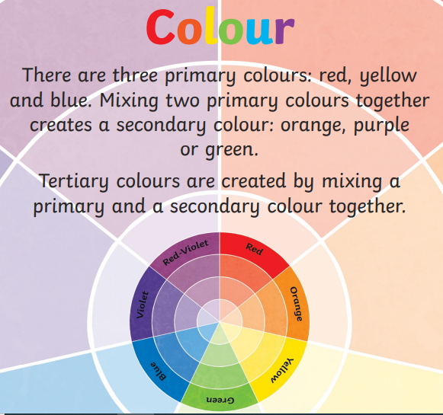
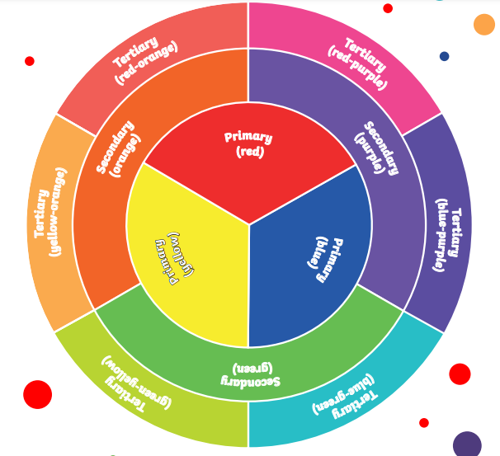

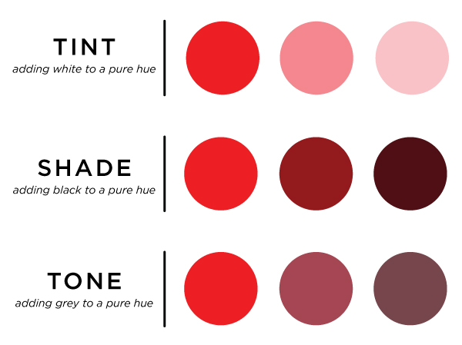

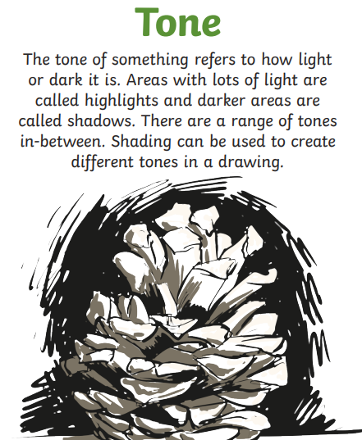
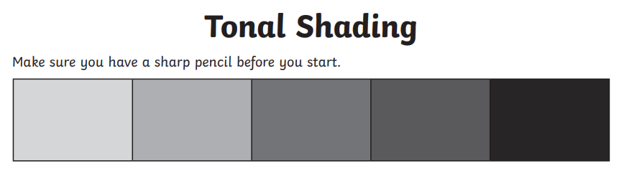
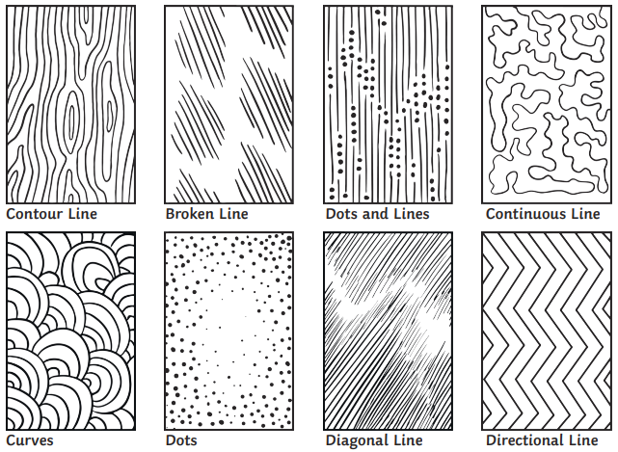
Appendix C: Drawing skills
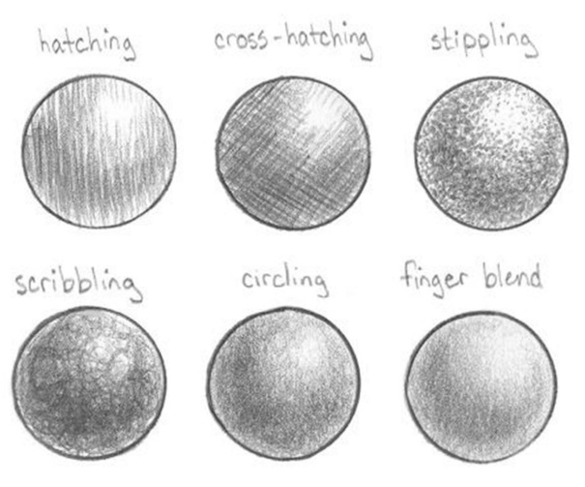
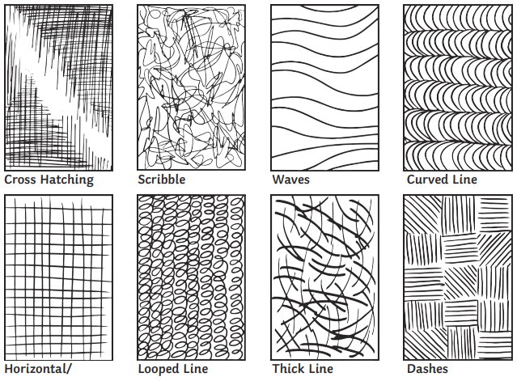

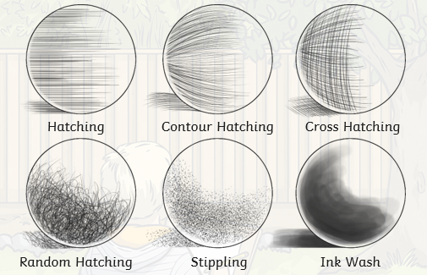

Appendix D: Art core concepts/key vocabulary
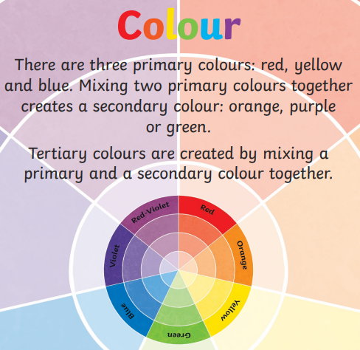 | 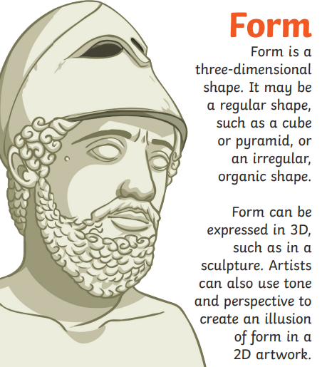 | 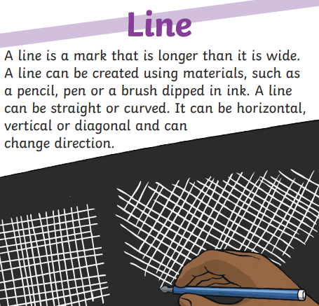
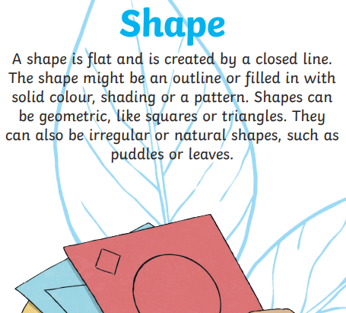 | 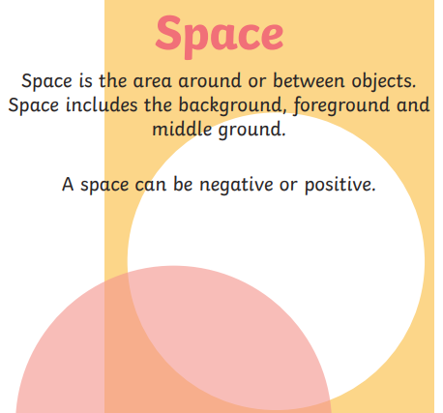 | 

