About the BERT Award

We are working towards the BERT Award !
Building Effective Relationships Together (BERT) – is the name of the new Derbyshire Relationships and Sex Education Award Programme which our school is working towards.

Through the BERT Award we aim to:
- Develop our Relationships and Sex Education (RSE) in school

- Further develop positive relationships in the school community

- Reduce stigma around asking for help and support on sensitive issues, such as puberty, sexual health, online relationships and consent

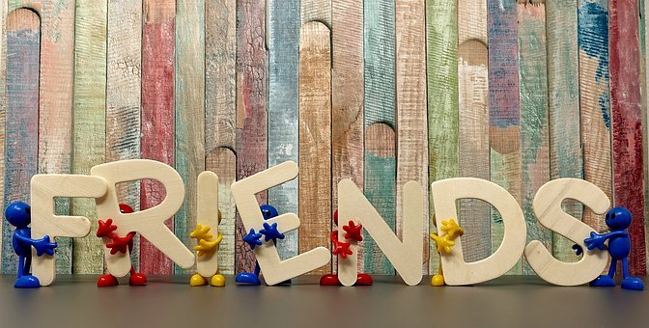

Why is this area of education important?
Where children and young people have good friendships and connections with others, this supports their safety, mental health and wellbeing, ability to take part in lessons and to achieve well in their learning.

Research tells us that quality relationships and sex education (RSE) helps to keep children and young people safe and reduces risky behaviour.
.
For more information about the Award please contact Mrs Wood or Miss Austin
Check out the resources on our school website to support you in talking to your child about Relationships and Sex Education.

