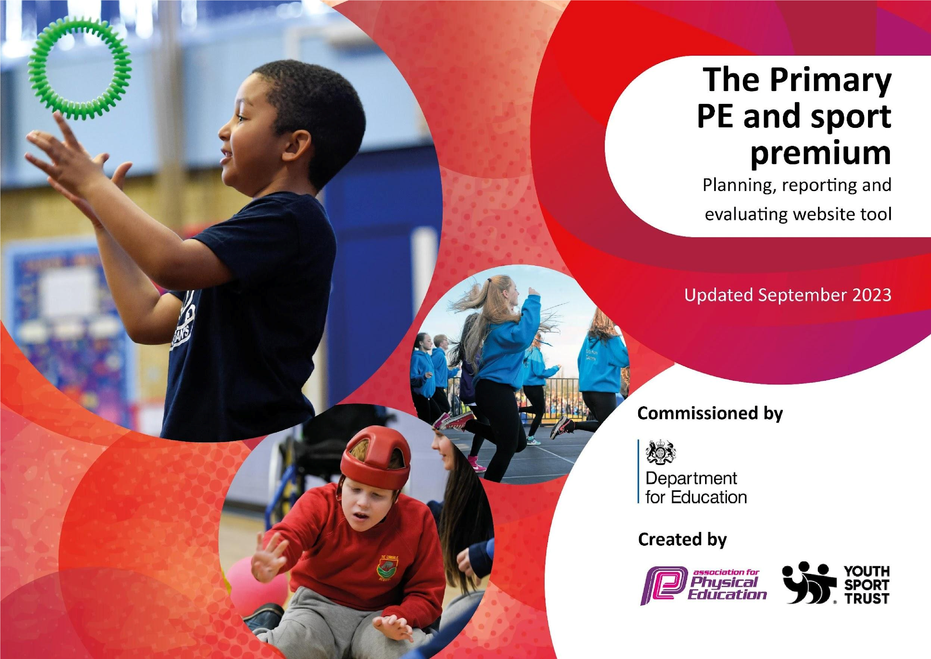

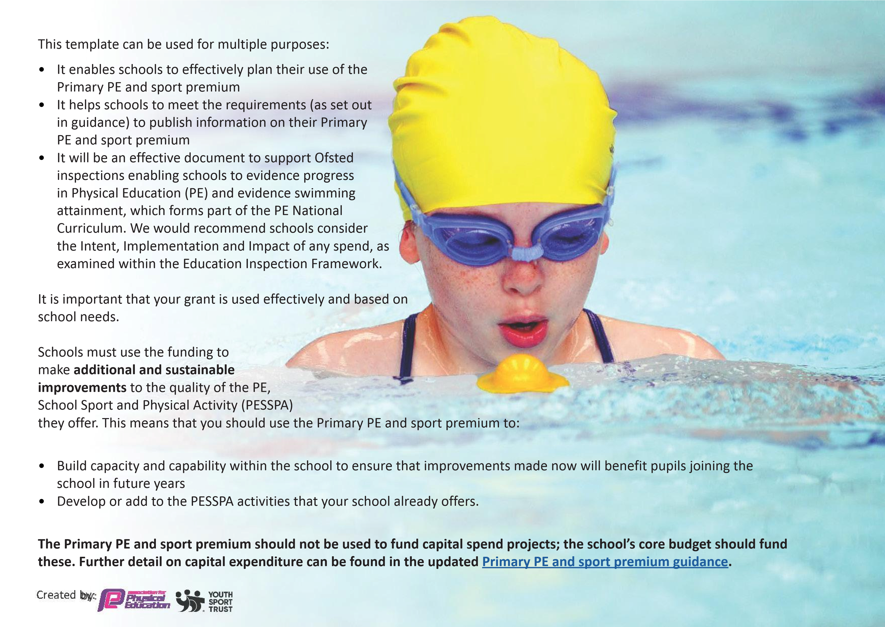
The Primary PE and sport premium guidance, outlines 5 key priorities that funding should be used towards. It is not necessary that spending has to meet all the key priorities, you should select the priorities that you aim to use any funding towards.
Although completing this template is not a requirement for schools, schools are required to publish details of how they spend this funding. Schools must also outline what the impact this funding has had on pupils’ PE and sport participation and attainment and how any spending will be sustainable in the future. All funding must be spent by 31st July 2025.
The Department for Education has worked closely with the Association for Physical Education (afPE) and the Youth Sport Trust (YST) to develop this template and encourages schools to use it. This template is an effective way of meeting the reporting requirements of the Primary PE and sport premium.
We recommend you start by reflecting on the impact of current provision and reviewing your previous spend.
Activity/Action | Impact | Comments
- Teachers increase confidence at planning for PE | - Effective teaching of PE and PE profile increase | - Aim to increase this with an adult and playground leaders conducting games together- look at employment of playground leaders  - Consider training year 6 in 2025/2026.  - Continue with a PE specialist but across KS1 in the year 2024/2025.
This planning template will allow schools to accurately plan their spending.
Action – what are you planning to do | Who does this action impact? | Key indicator to meet | Impacts and how  sustainability will be achieved? | Cost linked to the action
Use the leisure centre to teach high quality PE | Staff have the space and the ability to teach high quality PE to all pupils in KS2 | Key indicator 2 -The engagement of all pupils in regular physical activity – children engage in at least 60 minutes of physical activity per day, of which 30 minutes should be in school.  Key indicator 4: Broader experience of a range of sports and activities offered to all pupils. | More pupils meeting their daily physical activity goal, more pupils encouraged to take part in PE and  Sport Activities. | £6400
Specialist PE teacher | Outside agency teacher stuff | Key Indicator 4: . Broader experience of a range of sports and activities offered to all  pupils. Allowing for children to be taught a broad and balanced curriculum.  Key Indicator 3: The profile of PE and sport is raised across the school as a tool for whole school improvement.  Specialists will ensure that all children are engaged in the PE lessons as well as supporting with adapting the current PE curriculum plans, to develop | More children engage in a range of sporting events, ensuring that they are being taught a range of PE skills such as sportsmanship, teamwork etc. | £7000
CPD for teachers/TA’S | Primary generalist teachers. | Key Indicator 1: Increased confidence, knowledge, and skills of all staff in teaching PE and sport.  Key indicator 5: Increased participation in competitive sport. | Primary teachers are more confident to deliver effective PE supporting pupils to undertake extra activities inside and outside of school, including teaching water safety and swimming and as a result improved % of pupil’s attainment in PE. | £275

 |  | knowledge of a range of sports available.
Competitive sport events | Children at St Oswald’s will be taking part and be supported by school staff. | Key Indicator 5: Increased participation in competitive sport. Children will be taking part in competitive sports across the school.  Key Indicators 4: Broader experience of a range of sports and activities offered to all pupils. Pupils can experience a range of sports outside of the school and be part of a bigger team sports sport. | Children grow in confidence to take part in a sport outside of school. | £500
New PE Curriculum | Teaching stuff/PE specialist | Key indicator 3: The profile of PE and sport is raised across the school as a tool for whole school improvement  Key Indicator 4: Broader experience of a range of sports and activities offered to all pupils | The new curriculum will also have a range of new sports and ensure that there is clear progression across the school from Early Years to Year 6. | £600
Update PE equipment and resources | Children and staff are able to deliver and experience a broad and balanced curriculum with the new equipment that is going to be bought | Key Indicator 2: Engagement of all pupils in regular physical activity. Further engagement in a range of different activities as we will have the equipment available.  Key indicator 3: The profile of PE and sport is raised across the school as a tool for whole school improvement. | Children will be able to experience a range of different sports with the new equipment. | £ 1800

Total budget spent: | £16,575
This template will be completed at the end of the academic year and will showcase the key achievements schools have made with their Primary PE and sport premium spending.
Activity/Action | Impact | Comments
Meeting National Curriculum requirements for swimming and water safety.
What percentage of your current Year 6 cohort are able to perform safe self-rescue in different water-based situations? | 78.5% | Most of the children have a strong understanding on what to do to self-rescue if needed as we have taught them through assemblies/PSHE about water safety as well as when they are in the water. Some children with additional needs may find this a little hard due to their understanding.
Priority should always be given to ensuring that pupils can perform safe self-rescue even if they do not fully meet the first two requirements of the National Curriculum programme of study
Question | Stats: | Further context  Relative to local challenges
What percentage of your current Year 6 cohort can swim competently, confidently and proficiently over a distance of at least 25 meters? | 28/32 87.5% | We ensure our KS1 and LKS2 Pupils attend swimming
What percentage of your current Year 6 cohort can use a range of strokes effectively [for example, front crawl, backstroke, and breaststroke]? | 25/32  78.15% | Children receive their final swimming lessons in Year 4.

If your schools swimming data is below national expectation, you can choose to use the Primary PE and sport premium to provide additional top-up sessions for those pupils that did not meet National Curriculum requirements after the completion of core lessons. Have you done this? | Yes/ | No | This has not been required. | This has not been required.
Have you provided CPD to improve the knowledge and confidence of staff to be able to teach swimming and water safety? | Yes/No |  |  | We use swimming teachers from the Leisure centre who are trained at teaching the skills and knwoeldge of swimming.
Signed off by:
Head Teacher: | Rebecca Wood
Subject Leader or the individual responsible for the Primary PE and sport premium: | Laura Peach
Governor: | Peter Blundell
Date: | September 2024

