‘Learning and Growing Together’
December 2025 Newsletter
Well done to all those children who took part in the Tag Rugby event and the Hockey Tournament at QEG’s, St Oswald’s children did really well they were gracious in their wins and worked well as teams as well as showing fantastic sportsmanship within their team and towards other teams.
Year 6 visited the Imperial War Museum last month which really helped bring their learning alive. I really enjoyed looking at the amazing Anderson Shelters which were created by the Year 4 children- fabulous creations!
The Friends of the School held their first event – a Film Night which was very well attended. Thank you to the team which work hard to allow these events to happen.
Children in Need Fundraising raised over £200- a good amount which is going to a wonderful cause. The Shoe Box Appeal has seen a number of shoe boxes coming into school which will go to children who are not as fortunate as us.
The School Day
Doors will open at 8.45 am Children will be able to come into school at 8.45am.
Children in classes in the annex (Year 4, 5 and 6) will come to school via the ‘Kissing Gate’ near the new play area where a member of staff will greet them, and they will be able to walk to their class independently. This will be either Mr Armstrong our caretaker or myself.
Children in year 3 will enter school via the blue door on the playground which leads into the main school building.
Infant children will go in via their classroom doors and parents can still bring their children onto the playground and collect at the end of the day.
All doors and Playground gates will close at 8.55am. Registers will be taken between 8.55 and 9am.If your child comes in after 8.55 am they need to be taken to Miss Simons in the school Office. Learning will begin at 9am. The end of the day is 3.15pm
We would advise that due to congestion on the playground and the sheer number of pupils we have that you remain considerate and patient around the school gates. If you have a child in Key Stage 2 you may continue with the arrangement of meeting near the church as this also gives your child independence when leaving school. If waiting by the church please ensure you are visible to the class teacher and wave or make eye contact. Once they see you and let your child go, the parent is then responsible for ensuring the child crosses the road safely.
Children in year 5 and 6 can walk home on their own (or walk to a chosen meeting place) if this is going to happen, we will need confirmation, and an MS Teams form will be sent out at the beginning of the academic year in relation to this
We would suggest that when picking up your child you pick up your youngest child first.
We have an Open Door Policy, if you have any queries or would like to speak to your child’s class teacher then there is more time at the end of the day; alternatively, you can make an appointment with your child’s class teacher, or Mrs Wood, to discuss anything confidentially.
Contacting Staff; Staff will respond to emails between 8am and 5pm. Please allow 24 hours for an email response. If you wish to contact a member of staff or arrange an appointment, please contact the school office who will arrange with the class teacher for a convenient time to meet.

Uniform;
Uniform is available to purchase in school. Please ensure you label everything!!!!
Our expectation is that you wear the full school uniform- no black skirts, shorts or trousers. Boots are not to be worn to school.

PE Kits- Our expectation is that the school PE Kit is worn to school- No colourful leggings, football shorts or other sports gear. If pupils do not come in the correct kit, we will provide spares and ask them to change.

We do have a range of pre-loved clothes which we can provide for families if you require.

Please do not allow your child to wear jewellery to school. They will be asked to remove jewellery and place it in an envelope for safe keeping. If a child has their ears pierced and they are in KS2 studs can be worn, if they are in KS1 or EYFS no piercings are permitted.

Boots; At this time of the year the weather is getting cold and wet- we are aware that children are wearing boots to walk to school. Please can you ensure they have their school shoes so that they can change into them when they get to school.

Safeguarding
The Designated Safeguarding Lead at St Oswald’s is Mrs Wood; Mrs Mansfield is the Deputy Designated Safeguarding Lead. If you have any concerns that a child is suffering or at risk, then please call Starting Point on 01629 533190/01629 535353
Online Safety
Please click on this link for information on how to set up parental controls on your broadband at home.

https://www.internetmatters.org/parental-controls/networks-wifi/

Remember parental controls (although important) are not the only solution as they only prevent access to certain types of websites. Conversations at home about
responsible online behaviour are the best forms of safety.

Mobile Phones; Governors have requested that the school Playground becomes a mobile free zone. Whilst you are on the school playground, please refrain from using your mobile phone.
Please do not take any photos of children on the school site or at school events. This is to protect our children across the school.
Cold Weather Alert;
Derbyshire have offered guidance;
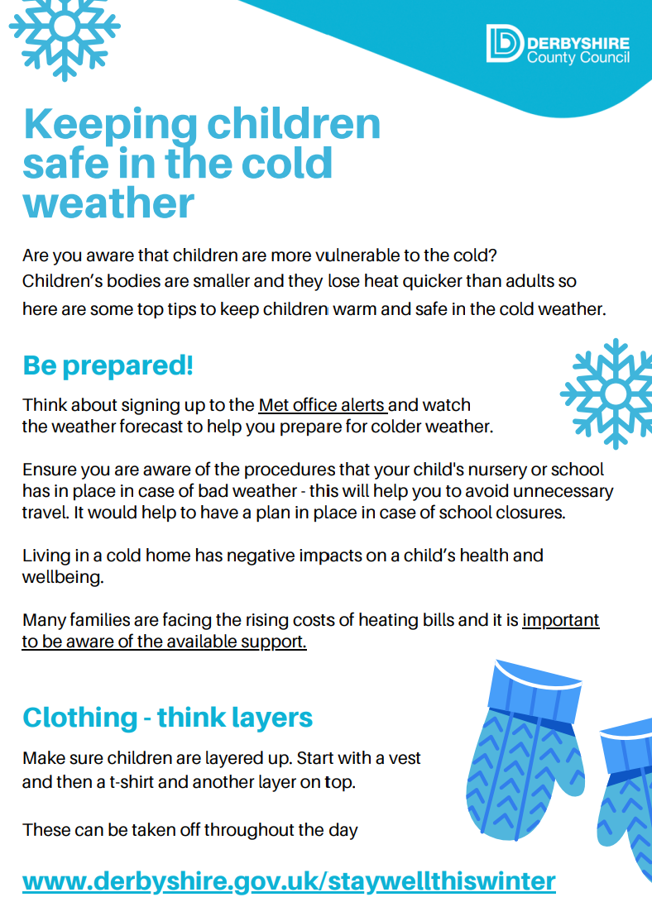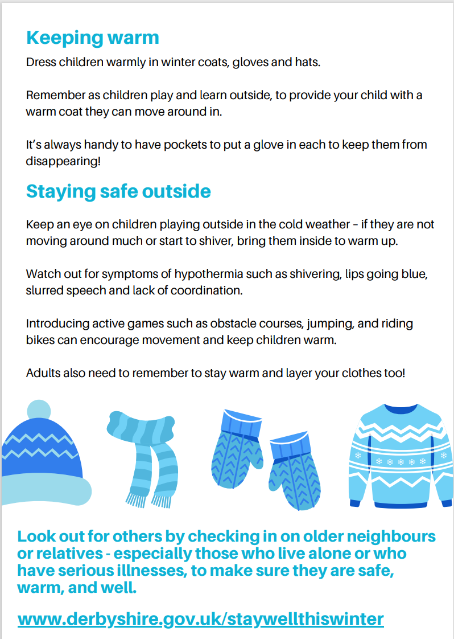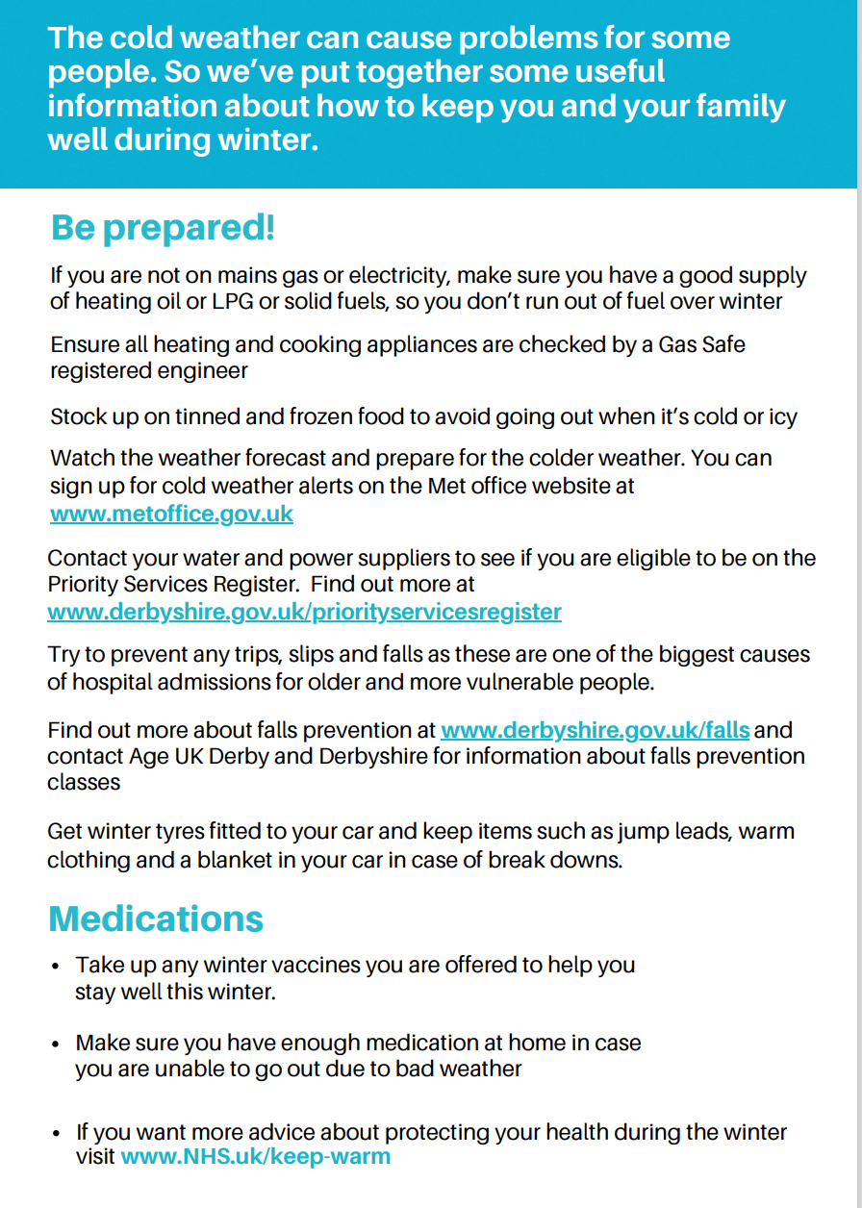
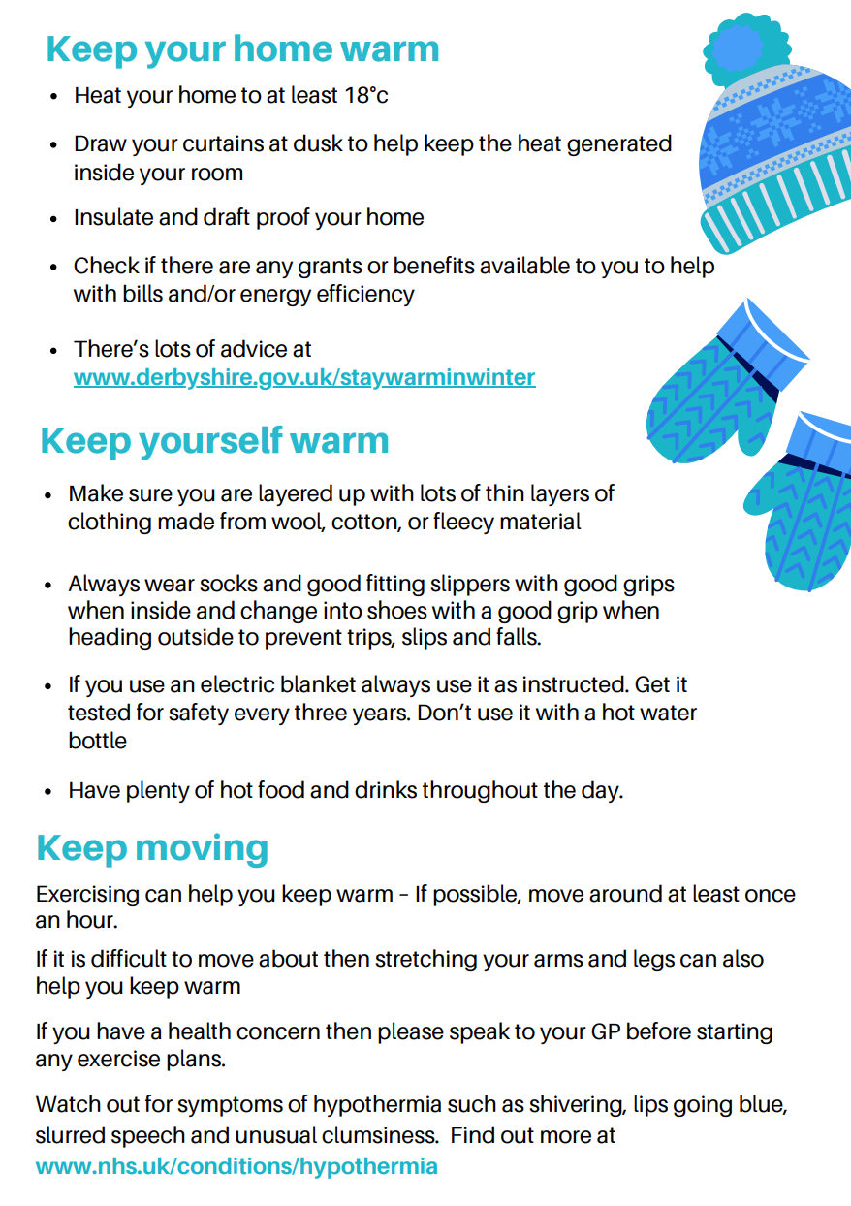

Travelling to school

The beginning and end of the school days are extremely busy on Mayfield Road outside school. Please think very carefully where you park. It is safer to arrive 5 minutes early and park away from the school gates and walk the last 5 minutes to school. You will have noticed that there are signs outside school restricting parking, and this will be monitored by the Traffic Warden. Our motto is ‘Park Away Stride Today!’ Where possible please walk, scoot or cycle to school. You can park in the carparks in Ashbourne for free after 3pm with your Derbyshire dales parking disc displayed.
Cars Idling; Please can we ask you to think when you park and turn off your car engines and not have them idling. The pollution form the fumes in the air is not good for our children’s health as they walk to school and wait on the playground. It is impacting on our local climate. Thank you.
Attendance
The register is taken between 8.55-9am. If your child comes to school after this time they will be marked as late.
Attendance at school is crucial- every day your child misses equate to lost learning. If your child is unwell then please contact the school office on the first day of absence. The phones will be manned from 8am. Please email the school office if your child is unwell not the class teacher; info@st-oswalds.derbyshire.sch.uk
If Miss Simons or Mrs Waring have not heard from you regarding your child’s absence by 9.00am then they will call you. The Attendance policy is on the school website. Holidays are not permitted during term time. Attendance is rewarded with certificates monthly; these rewards are detailed on the school website. If your child arrives after 9am they will be given a ‘U’ mark and this will go against their attendance.
Leave of absence (this could be a pre-arranged appointment) needs to be requested. A leave of absence form can be requested at the school office. The DFE have provided updates on school attendance which can be found here; DfE external document template (childrenscommissioner.gov.uk) Our attendance policy reflects the changes.
Parent Pay;
Please check your child’s Parent Pay account and ensure any outstanding bills are paid. Miss Simons and Mrs Waring are looking at what outstanding payments are on parent pay and will be in contact over the next few weeks.
Fruit in school

Fruit in school is free for Key Stage 1 children. We ask that children try the fruit and have a single piece if they are not keen. In Key Stage 2 the children can bring in a healthy snack to school- fresh fruit/vegetables, etc. (No nuts due to allergies and no pepperoni sticks, no items wrapped in wrappers, etc.) We are a health promoting school and we have pupils who have allergies therefore we need to be mindful of what we bring into school
Governors
Reading and Homework
Children are on their reading journey now and are collecting their stars in preparation for their first reading award of a Bronze badge. Children are now on their journey to getting Bronze badges- well done all- super reading.
Helping in school
If you would be interested in helping in school; listening to children read helping in lessons and supporting the school in any way then please drop us an email or pop and see Mrs Wood or one of the class teachers. If you are interested in helping or you have a relative that is interested in helping then we would love to have you be part of the team.
Our Golden Rules and Classroom Values
We have extremely high expectations of behaviour within the school. We expect every child to follow the Golden Rules and our classroom values. We have updated our Behaviour Policy and Exclusion Policy which are on the school website.
Values Corner
This half term our Value will be focused on building a Strong Community; Values which we held dear- friendship, trust and mutual encouragement are important for building a strong community

Music Opportunities
Extra-curriculur Music is now up-and-running:
- Ukelele group for Y5-Y6 on Tuesday lunchtimes. Free. Run by Mrs Clarke. Y4 welcome to join after Christmas.
- Recorder group for Y2-Y6 on Monday lunchtimes. £2. Run by Miss Light
- Instrument tuition available: piano, recorder, sax, flute, oboe, clarinet.

Dates for the term ahead;
Autumn term 2025
2nd December | Year 5 pupils visit The Space Centre
5th December |   Christmas Jumper day-  Wear a Christmas Jumper and bring in a Tombola Prize.
8th December | Year 3 pupils visit St Oswald’s to take RE into the Church
11th December | Christmas Fair 5pm-7pm
16th December | School Infant Nativity Play 2pm
17th December | School Infant Nativity Play 2pm
18th December | School Infant Nativity Play 2pm
19th December | Carols in Church- 9am  Pm Christmas party and lunch  Last day of term
Return to school on Monday 5th January

