MATHS
We will continue our topic on fractions before moving onto decimals this half term. The group will explore improper fractions and mixed fractions and learn how to convert between the two. Children will then be introduced to decimals, firstly through exploring tenths and then hundredths. They will use their knowledge to help to compare and order decimals. The children will continue to practise recalling multiplication and division facts for multiplication tables up to 12 × 12 and access TT Rockstars and Doodle daily.

ART
We will be researching and using a variety of media to create expressive drawings of eyes. The group will then explore and make sculptures of a dragon eye using clay. Children will think about carving and also building up to create texture within their sculpture.
ENGLISH
Our model text is ‘How to Train your dragon’ by Cressida Cowell. We will be focusing our learning on myths this half term. Children will design their own dragon story (myth) linked to ‘How to train your Dragon’. They will include key features e.g. setting and character descriptions, paragraphs, expanded noun phrases and adverbial phrases within their independent writing. Towards the end of the term we will be learning Quatrain poems. In SPAG we will recap casual conjunctions, fronted adverbials, direct speech and prepositional phrases. We will be continuing to spell the common exception words accurately.
SCIENCE
Our new Science topic is ‘Electricity’. Children will learn to construct simple series electrical circuits and investigate how a switch works within a circuit. They will also be introduced to conductors and insulators.

HISTORY
We will be learning about the Anglo-Saxons. Children will explore reasons for Anglo-Saxon migration including environmental, economic and political factors. They will learn about the daily life of Anglo-Saxons and gain key knowledge about Saxon culture such as their pagan beliefs and myths.

MUSIC
Children will continue to study the Ukulele with Mrs Morgan on a Tuesday afternoon. In addition, they will be looking at dimensions and percussion.

GEOGRAPHY
We will be using maps to identify locations of ancient Anglo-Saxon settlements and British territories. The class will be given an insight into how natural geography influenced the settlement of Anglo-Saxons. They will compare the differences and similarities between Anglo-Saxon and Roman settlements.
RE
Our key question this half term is ‘What can we learn from religions about deciding what is wrong and right?’ Children will consider how we should care for others and the world, and discuss why it matters. They will learn what matters most to Christians and Humanists and discuss if religions help people to be good.

SPANISH
Building on our topic of face and body parts last half term, we will be learning about feeling unwell, focusing on aches and pains and doctor role play in Spanish. Later in the half term, children will be introduced to jungle animal nouns and learn to say and write simple model sentences using these.

PE
This half term PE will continue on a Wednesday afternoon at school. Within this, we will be focusing on Rounders and Cricket.
COMPUTING
The children will continue to learn programming principles and focus on repetition in shapes this half term. We will use Turtle Academy and Fins logo to support our learning.
‘TRADERS AND RAIDERS’
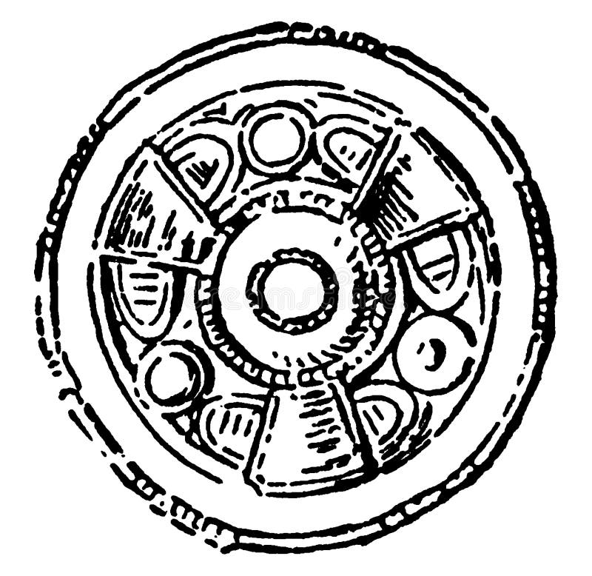
Mrs Bunting and Miss Austin
Summer 1-Year 4

PSHE
Our key question this half term is ‘Does money make you happy?’. The children will discuss how to manage money and the importance of money in people’s lives. We will also explore the concepts of interest, loan, debt and tax.

