‘Learning and Growing Together’
April 2026 Newsletter
What a super month March was…. It was great to see the children involved in World Book Day and we were privileged to have a Story teller visit the school.


This was a wonderful way to enrich the children’s experiences and provided them with an opportunity to be inspired by stories and books.
I am hoping that many of you will have purchased a book with your world book day voucher. There were some lovely ones that you could choose from.
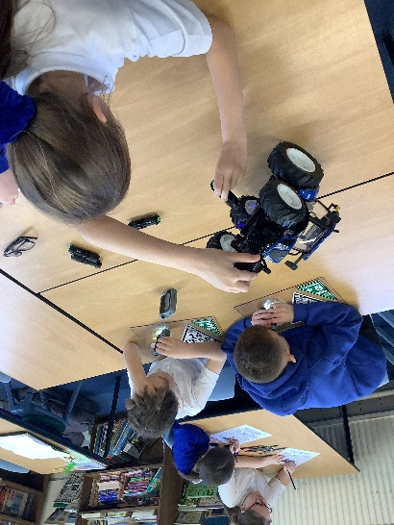
We were delighted to welcome the Rural Crime Team, who led a collective worship on keeping animals safe in our rural community, recognising rural crime and what to do if you witness it. After the assembly they ran hands-on sessions with Year 5 and Year 6 (30 minutes each), where pupils printed and analysed fingerprints, solved a crime case and used UV torches and magnifying glasses to investigate evidence from a stolen tractor — a brilliant, engaging session that brought important safety messages to life. 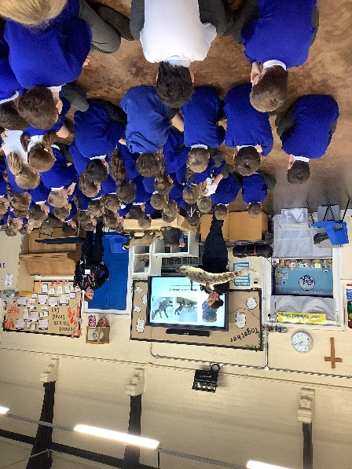 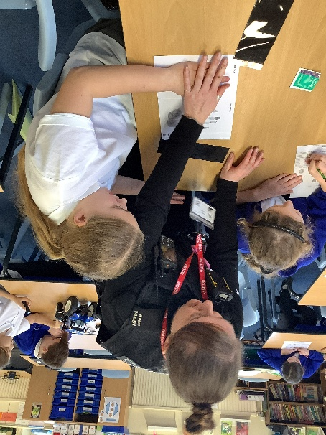
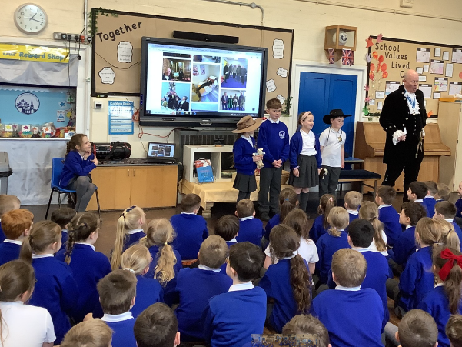
Sir Richard Fitzherbert visited the school and talked about his role as the High Sheriff. This was a really informative session

Thank you to all who responded to the Annual Questionnaire. We take your feedback seriously and will address areas within the School Improvement Plan. All feedback can be found on the school website St Oswald's C of E Primary - Questionnaires
The Year 4 children visited the farm and fed lambs and learnt about the origins of food and had a fabulous time. The Year 1 children visited Peak Wildlife Park to end their learning this term.
It was lovely to see so many faces at the combined Mother’s Day service and Easter Service.
Staffing Updates
We currently have two vacancies within school which are advertised on Derbyshire County Council Jobs website. Mrs Harrison has changed her career and is now working within health and fitness.
Supporting our families- sign posting for support


The Derbyshire Local Offer is in place to support children and young people with special educational needs and disabilities (SEND), as well as their parents and carers. It provides clear information about available services and provision, including how to apply for an assessment, early years support, education and learning, care services, preparing for adulthood, health and wellbeing, financial support and travel and transport. The Derbyshire Local Offer contains useful resources for families. The Local Offer includes a directory of local SEND services, support groups, and activities, empowering families to make informed decisions and enhance the quality of life for children and young people with SEND in Derbyshire.
The School Day
Contacting Staff; Staff will respond to emails between 8am and 5pm. Please allow 24 hours for an email response. If you wish to contact a member of staff or arrange an appointment, please contact the school office who will arrange with the class teacher for a convenient time to meet.

We are in the process of updating our Communications Policy and Home School Agreement. Drafts of these can be found here. download.asp

Uniform;
Uniform is available to purchase in school. Please ensure you label everything!!!!
Our expectation is that you wear the full school uniform- no black skirts, shorts or trousers. Boots are not to be worn to school.

PE Kits- Our expectation is that the school PE Kit is worn to school- No colourful leggings, football shorts or other sports gear. If pupils do not come in the correct kit, we will provide spares and ask them to change.

We do have a range of pre-loved clothes which we can provide for families if you require.

Please do not allow your child to wear jewellery to school. They will be asked to remove jewellery and place it in an envelope for safe keeping. If a child has their ears pierced and they are in KS2 studs can be worn, if they are in KS1 or EYFS no piercings are permitted.

It is lovely to see the sun beginning to poke through the clouds- please can you ensure your child has a sunhat or cap that they keep in school for those sunny days, and that long lasting sun cream is applied before school!

Safeguarding
The Designated Safeguarding Lead at St Oswald’s is Mrs Wood; Mrs Mansfield is the Deputy Designated Safeguarding Lead. If you have any concerns that a child is suffering or at risk, then please call Starting Point on 01629 533190/01629 535353.
If you require any support then please contact Mrs Wood who can support through sign posting to the Early Help team.
Online Safety
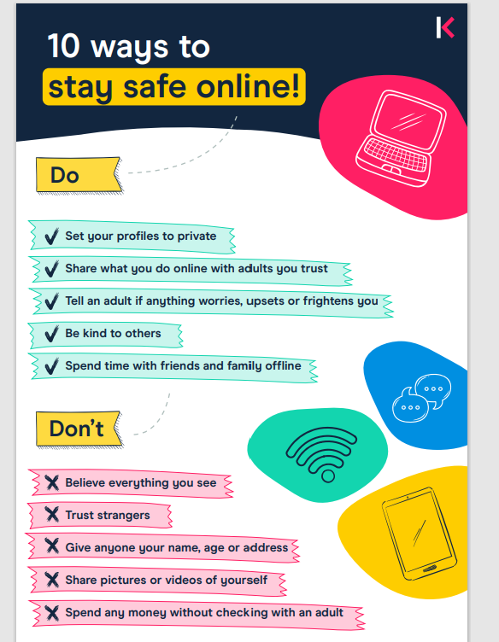


Mobile Phones; Governors have requested that the school Playground becomes a mobile free zone. Whilst you are on the school playground, please refrain from using your mobile phone.
Please do not take any photos of children on the school site or at school events. This is to protect our children across the school.

Travelling to school

The beginning and end of the school days are extremely busy on Mayfield Road outside school. Please think very carefully where you park. It is safer to arrive 5 minutes early and park away from the school gates and walk the last 5 minutes to school. You will have noticed that there are signs outside school restricting parking, and this will be monitored by the Traffic Warden. Our motto is ‘Park Away Stride Today!’ Where possible please walk, scoot or cycle to school. You can park in the carparks in Ashbourne for free after 2pm with your Derbyshire dales parking disc displayed.
Cars Idling; Please can we ask you to think when you park and turn off your car engines and not have them idling. The pollution form the fumes in the air is not good for our children’s health as they walk to school and wait on the playground. It is impacting on our local climate. Thank you.

Attendance
The register is taken at 8.55am. If your child comes to school after this time they will be marked as late ‘L’. If your child arrives after 9am they will be given a ‘U’ mark and this will go against their attendance.
Attendance at school is crucial- every day your child misses equate to lost learning. If your child is unwell then please contact the school office on the first day of absence. The phones will be manned from 8am. Please email the school office if your child is unwell not the class teacher; info@st-oswalds.derbyshire.sch.uk
If Miss Simons or Mrs Waring have not heard from you regarding your child’s absence by 9.00am then they will call you. The Attendance policy is on the school website. Holidays are not permitted during term time. Attendance is rewarded with certificates monthly; these rewards are detailed on the school website.
Leave of absence (this could be a pre-arranged appointment) needs to be requested. A leave of absence form can be requested at the school office. The DFE have provided updates on school attendance which can be found here; DfE external document template (childrenscommissioner.gov.uk) Our attendance policy reflects the changes.
Parent Pay;
Please check your child’s Parent Pay account and ensure any outstanding bills are paid. Miss Simons and Mrs Waring are looking at what outstanding payments are on parent pay and will be in contact over the next few weeks.
Fruit in school

Fruit in school is free for Key Stage 1 children. We ask that children try the fruit and have a single piece if they are not keen. In Key Stage 2 the children can bring in a healthy snack to school- fresh fruit/vegetables, etc. (No nuts due to allergies and no pepperoni sticks, no items wrapped in wrappers, etc.) We are a health promoting school and we have pupils who have allergies therefore we need to be mindful of what we bring into school
Governors
Reading and Homework
Children are on their reading journey now and are collecting their Bronze/Silver/Gold stars and reading awards- well done all- super reading.
Helping in school
If you would be interested in helping in school; listening to children read helping in lessons and supporting the school in any way then please drop us an email or pop and see Mrs Wood or one of the class teachers. If you are interested in helping or you have a relative that is interested in helping then we would love to have you be part of the team.
Our Golden Rules and Classroom Values
We have extremely high expectations of behaviour within the school. We expect every child to follow the Golden Rules and our classroom values. We have updated our Behaviour Policy and Exclusion Policy which are on the school website.
Values Corner
This half term our Value will be focused on building a Strong Community; Values which we held dear- friendship, trust and mutual encouragement are important for building a strong community

Music Opportunities
Extra-curriculur Music is now up-and-running:
- Recorder group for Y2-Y6 on Monday lunchtimes. £2. Run by Miss Light
- Instrument tuition available: piano, recorder, sax, flute, oboe, clarinet.

The Trim Trail and Field
Now the weather is less wet the field and Trim Trail will be open for use. This area is still quite wet and muddy so we apologise if your child comes home muddy.

 Wellington Boot Amnesty 

We are looking to further develop the Trim Trail Area so it can be used more during the whole year. Due to how muddy this area is we are looking at having a bank of wellington boots and waterproofs.

We are asking for donations of wellington boots which your children have grown out of and you could donate to the school and any waterproof coats or trousers which could also be donated. You may be having a clear out at home during the Easter break and you may come across old wellies and clothing.

If you could start sending in any donations we would be very grateful.

Dates for the term ahead;
Summer Term 2026
Easter Holidays
Return to school Monday 13th April 2026
Wednesday 15th April | Dental Checks (5 year olds)
Thursday 30th April | Class Photos
Friday 1st May | Primary Arts Day Y5
Monday 4th May | Bank Holiday Monday- School closed
Monday 11th May | Year 6 Statutory Assessment
Tuesday 12th May | Year 6 Statutory Assessment  Year 4 St Oswald’s Church
Wednesday 13th May | Year 6 Statutory Assessment
Thursday 14th May | Year 6 Statutory Assessment
Friday 15th May | Year 6 Park and Olde Sweet Shop Treat
Tuesday 19th May | Year 4 @ St Oswald’s Church  Year 4 lead Collective Worship in school
Thursday 21st May | Year 2 and Year 6 – Workshop from the Fire Service
Friday 22nd May | Last day
Half Term
Monday 1st June | INSET Day
Tuesday 2nd June | Return to school
Monday 8th June | Phonics Screening Check this week for Year 1  Multiplication Check this week for Year 4 pupils
Tuesday 9th June | New EYFS Parents Meeting
Tuesday 16th June | Year 6 St Oswald’s Church
Wednesday 17th June | KS2 Sports Day am at the recreation ground  1pm; Year 2 Sports day on the playground- Parents to come to the new playground to watch their children
Thursday 18th June | 9.30am; EYFS Sports Day on the playground- Parents to come to the new playground to watch their children  1pm; Year 1 Sports Day on the playground- Parents to come to the new playground to watch their children
Friday 19th June | Father’s Day Service- 9am at St Oswald’s Church  Year 2 Sleepover- More details to follow
Tuesday 23rd June | 9am Year 6 at St Oswald’s Church  Year 6 Child led service
Friday 26th June | Denstone cricket tournament  Year 1 &2 Sponsored Walk  2pm Year 5 Ashbourne Park Big Sing
Friday 3rd July | KS 2 Sponsored Walk-  Year 2 Pupils Trip to Llandudno
Tuesday 21st July | 1pm Moving on Service
Thursday 23rd July | Year 6 leavers play

