Ancillary Staff 2025-2026
  Miss Simons  School Business Officer | Our School Office Team |   School Office Support
Miss Hamilton  School Cook | Our School Kitchen Team | Mrs Bridgart  School Catering Assistant
Our School Midday Supervisor Team
Mrs Waring |   Mrs Allen |   Mrs Blundell
  Mrs Mitchell |   Mrs Roper | 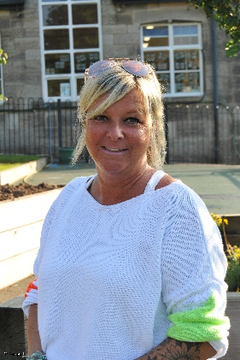  Mrs Wadley
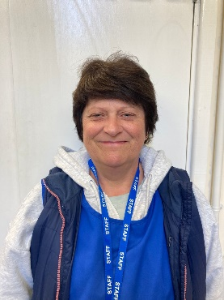  Mrs Bott | Mrs Mowatt | Ms Kyruta

