St Oswald’s Teaching Assistants;

Here are our team of Learning and Teaching Assistants
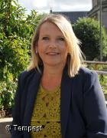  Mrs Seddon  HLTA | 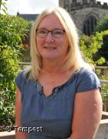  Mrs Shearer  HLTA | 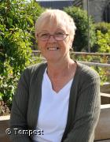  Mrs Yeomans  Teaching Assistant
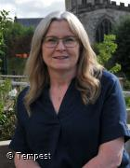  Mrs Richmond  HLTA | 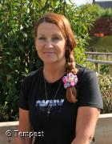  Mrs Beresford  Learning and Teaching Assistant | 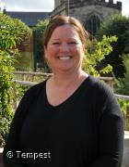  Miss Smith  Learning and Teaching Assistant
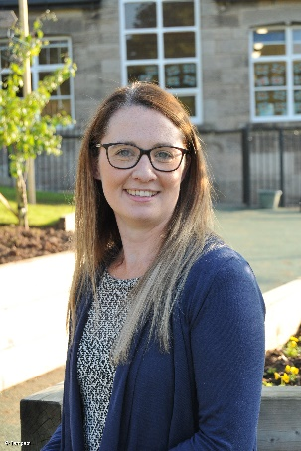  Mrs Bond  Learning Teaching Assistant | 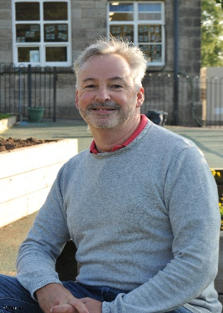  Dr Collinge  Learning and Teaching Assistant with QTS | 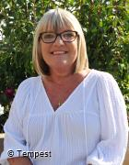  Mrs Dacre  Learning and teaching Assistant
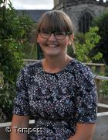  Mrs Bould  Learning and Teaching Assistant | 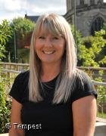  Mrs Maznenko  Learning and Teaching Assistant | 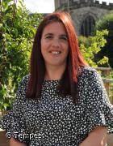  Mrs Williams  Learning and Teaching Assistant
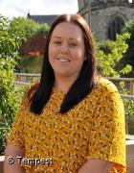  Mrs Oxspring  Learning and Teaching Assistant | Miss Cresswell  Learning and Teaching Assistant | 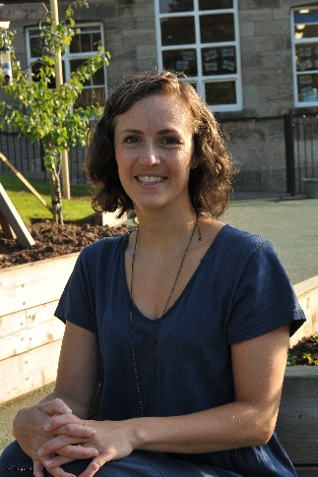  Mrs Morgan  Learning and Teaching Assistant
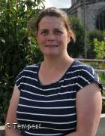  Mrs Blundell  Learning and Teaching Assistant | Mrs Shipley  Learning and Teaching Assistant

