
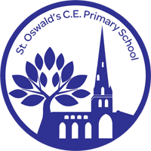
Pupil Guide to Using AI at
St Oswald’s CE Primary School
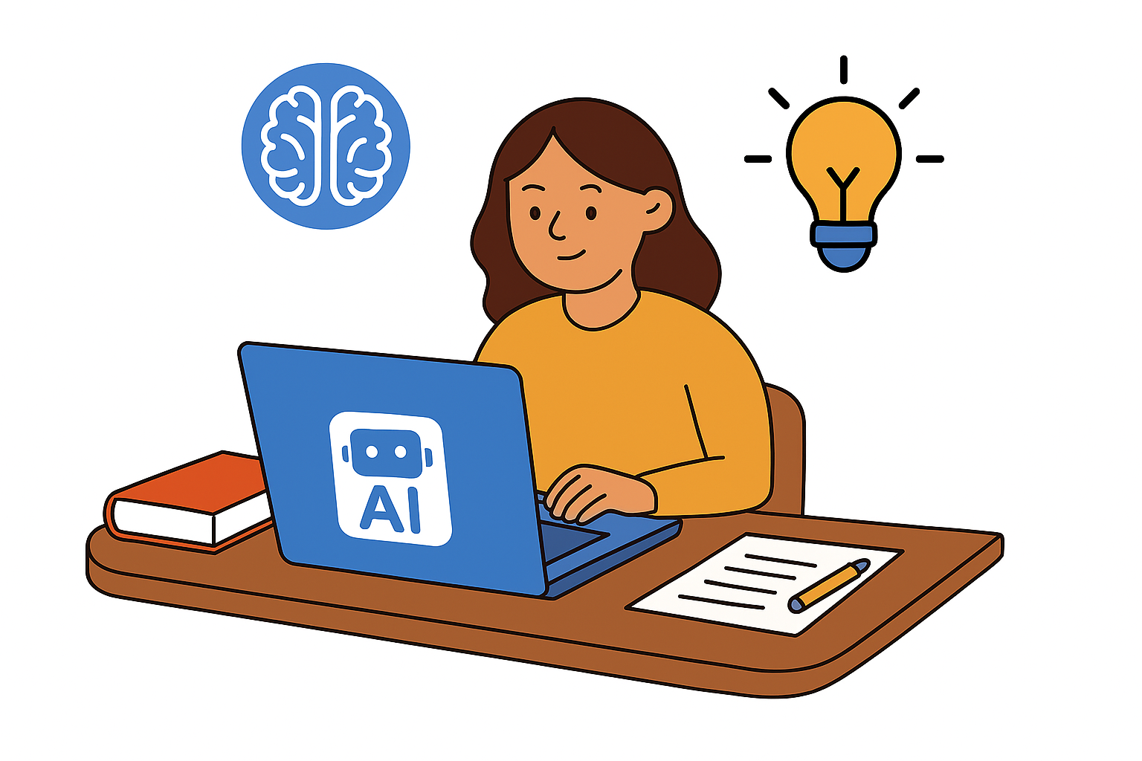

What is AI?
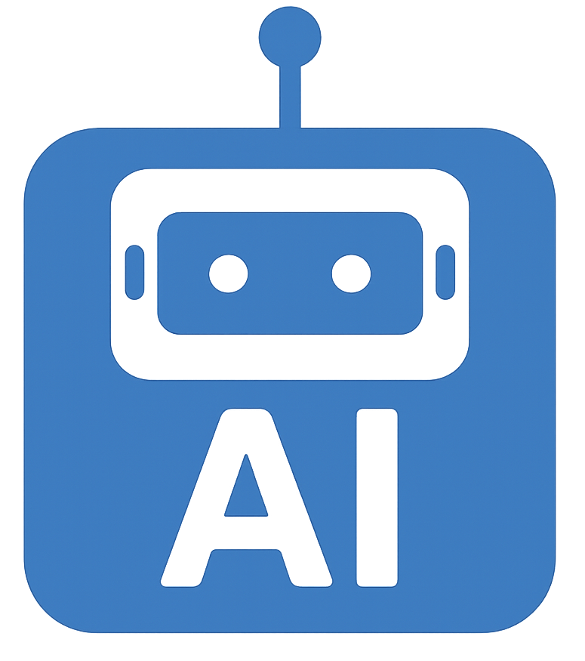
AI (Artificial Intelligence) is technology that can help us learn, create, and solve problems. It can write, draw, answer questions, and even help with planning and feedback. At school, we use AI to support learning - but it’s important to use it responsibly.

What You Can Do with AI
- Use approved AI tools to help with research, ideas, and creativity.

- Ask AI for feedback on your work but make sure it’s still your own.
- Explore how AI works and learn about its strengths and weaknesses.
- Use AI to help you understand tricky topics or practice skills.

What You Shouldn’t Do with AI
- Don’t copy and paste AI answers into your homework or assessments.
- Don’t use AI to pretend work is yours when it’s not.
- Don’t enter personal information (like your name or email) into AI tools.
- Don’t use AI tools that haven’t been approved by your teachers.

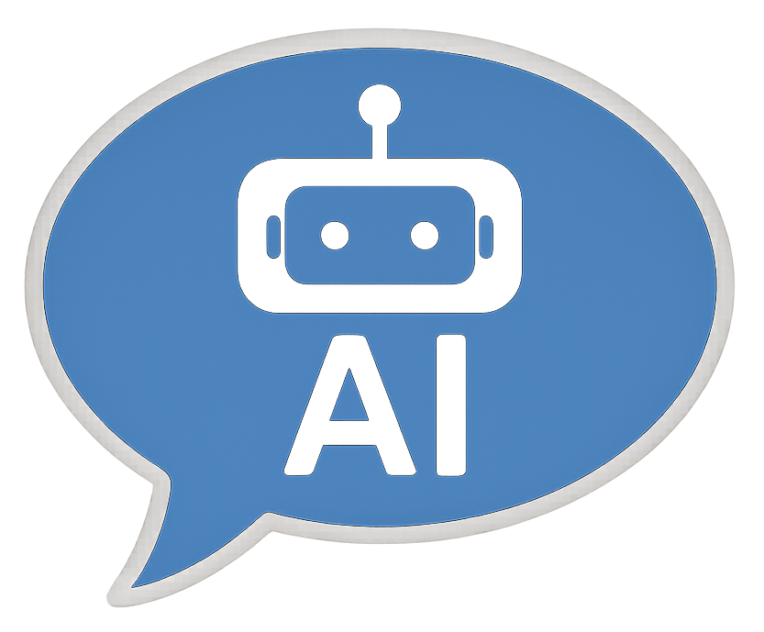
Being Honest About AI Use
If you use AI to help with your work, you must say so. This is called “referencing”, just like you would with a book or website. You’ll also be asked to sign a declaration saying your work is your own.

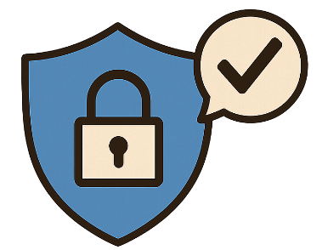
Staying Safe and Fair
- AI can sometimes get things wrong or be unfair, so always double-check.
- Your teachers will help you spot when AI might be biased or inaccurate.
- We use tools to check that work is original and not written by AI.
- You’ll learn how to use AI safely, ethically, and responsibly.

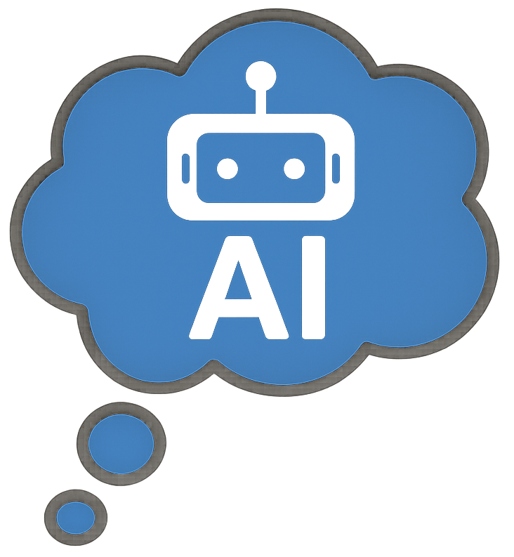
Learning About AI
You’ll have lessons and activities that teach you:
- How AI works
- What it can and can’t do
- Why it’s important to think critically
- How to use AI in a fair and safe way

Who Can Help?

If you’re unsure about using AI, talk to:
- Your teacher
- The school’s digital lead
- A trusted adult
They’ll help you understand what’s okay and what’s not.


Final Thought
AI is a powerful tool, but you are the most important part of your learning. Use AI to support your ideas, not replace them. Be curious, be honest, and be safe.
AI tools safe to use by and with children at St Oswald’s are; Teach Mate AI and Co Pilot.

