Our Teaching Staff Compliment Across the school
2026-2027
 | Mrs Wood Is the Head teacher of the school.  She is also the Designated Safeguarding Lead  Mrs Wood is the subject lead for Art and Modern Foreign Languages. Mrs Wood has overarching responsibility for Pupil Premium.
 | Mrs Mansfield is the Deputy Head teacher of the school  She is Deputy Designated Safeguarding Lead  Mrs Mansfield is SENDCo
 | Mrs Elliott is a class teacher. She is English Lead.
 | Mr Wood is a Class teacher. He is Subject Lead for Mathematics, PE and Religious Education in addition to this he is Mentor for ECT’s
 | Miss Birt is a Class teacher. She is subject lead for History and Geography as well as being Mental Health and Wellbeing Lead- she will be on maternity leave during this academic year.
 | Mrs Morgan is a Class teacher. She is subject lead for Computing and Music.
 | Miss Austin is a class Teacher. She is subject lead for Design and technology
 | Miss Fowell is a Class teacher. She is subject lead for RSE and PSHE- she will be on maternity leave during this academic year.
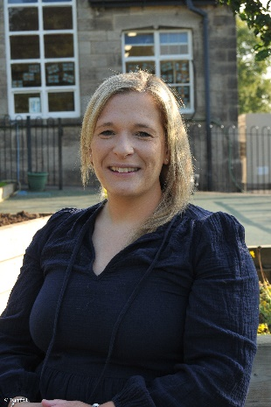 | Mrs Bunting is a Class teacher. Mrs Bunting is the lead for Science and Sustainability
 | Mr Cantellow is class teacher. He is an Early Careers teacher
 | Miss Bowden is class teacher. She is an Early Careers teacher

